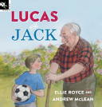
ELLIE ROYCE & ANDREW MCLEAN: Working Title Press

Every week Lucas' mum visits Great Grandpop at the nursing home. And every week Lucas waits for her outside. Waiting is boring! Until Lucas meets Jack. Jack is tricky and Jack is fun, and he is a great storyteller. Lucas & Jack is a great book for introducing young children to the idea that old people can be fun and that deep down we have more in common than we think. More importantly Lucas & Jack encourages children to ask questions, be curious, imaginative and empathetic. Shortlisted for the Speech Pathology Australia Book of the Year 2015

http://www.ellieroyce.com/

https://www.penguin.com.au/products/9781921504662/lucas-and-jack

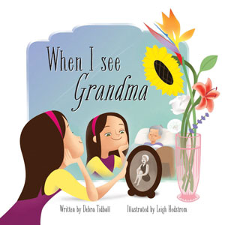
DEBRA TIDBALL and LEIGH HEDSTROM: WOMBAT BOOKS.
A young girl and her toddler brother visit their sleeping Grandmother in an Aged Care Home and help ‘brighten her dreams’ and the lives of the resident community.
A poignant celebration of life and love. Winner children’s book section of CALEB award 2014, shortlisted for Speech Pathology Book of the Year 2014 All author royalties donated to the Hazel Hawke Dementia Research and Care fund.
http://www.debratidball.com/
http://www.wombatbooks.com.au/when-i-see-grandma
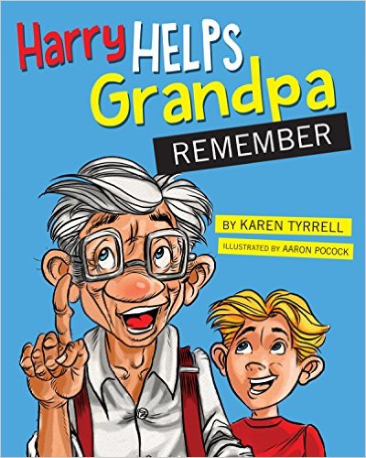
KAREN TYRRELL and AARON POCOCK: DIGITAL FUTURE PRESS
Harry and Grandpa love playing hide-and-seek together. Over time Grandpa becomes grumpy and forgetful, refusing to play games with Harry anymore. On Grand-parent’s Day, Grandpa becomes confused and lost. He couldn’t even remember Harry’s name. Then Harry discovers clever ways to boost Grandpa’s memory.
How does Harry help Grandpa remember? Endearingly told and full of hope, compassion and humour, ‘Harry’ provides a gentle introduction for children to the realities of Dementia and Alzheimer’s. Winner of RADF grant through Arts Queensland
http://www.karentyrrell.com/harry-helps-grandpa-remember/
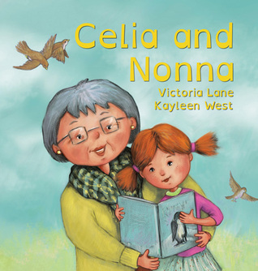
VICTORIA LANE and KAYLEEN WEST: FORD STREET

Celia and Nonna is a significant and heart-warming picture book about the special bond between children and grandparents – and what happens when life changes. Grandparent’s ageing is a universal experience, yet it is rarely told in picture book form. In this story, young Celia finds a delightful and positive way to navigate this confusing time.
http://www.victorialanebooks.com/
http://kayleenwest.com.au
http://www.fordstreetpublishing.com/ford/index.php/component/content/article/50-demo-content/books/263-celia-and-nonna

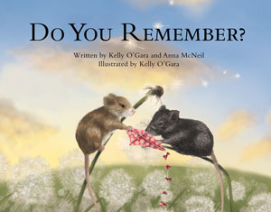
KELLY O’GARA and ANNA McNEIL: WOMBAT BOOKS
A beautiful exploration between a child and their ageing grandparent presented with outstanding illustrations, by newcomer illustrator, Kelly O'Gara.
Children will relate to the mice as they read the story and understand their grandparent's condition. The book can cater for multiple ageing conditions but specifically is focussed on explaining Dementia to children.
http://www.wombatbooks.com.au/do-you-remember

